Class of 2018 Post Prom
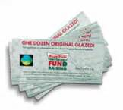
Fundraising Certificates: your customers choose to get their doughnuts whenever they want them. Each Certificate is redeemable for one dozen Original Glazed® doughnuts. Cost is $8.00
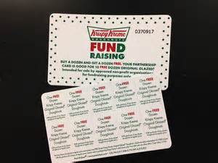
Valid for 10 FREE dozens – a GREAT value and a Fundraising exclusive! Each card has a value of over $80. With Card, your customers receive one dozen FREE Original Glazed® doughnuts with purchase of any dozen. Cost is $20.00
Any questions please contact Margaret Banks, Post Prom Coordinator at carvercentercelebration2018@gmail.com
-------------------------------------------------------------------------------------------------------------------
Name: ______________________________ Phone Number: ______________________
Student’s Name and Prime:__________________________________
Email: __________________________________________________
Please make checks payable to: Carver Center Foundation
BOGO Card ____ x $20.00 = $ _________
Certificates ____ x $ 8.00 = $_________ Total Enclosed = $ ________

Thank you for your order!

